**HIFI TECHNOLOGY**

**by**

**SALEH ISA SALEH**

**st/cs/nd/19/226**

**A SEMINAR PRESENTED TO THE DEPARTMENT OF COMPUTER SCIENCE, SCHOOL OF SCIENCE AND TECHNOLOGY, FEDERAL POLYTECHNIC MUBI, ADAMAWA STATE, NIGERIA**

**NOVEMBER, 2021**

**ABSTRACT**

*The authors will give an impression of the future HiFi system they dream of. Like a modern PC the dreamed system which is currently under development has Internet access and operates with a hard disk. Unlike a PC the HiFi system has a simple user interface. Thanks to its connection to a special peer-to-peer network the HiFi system provides easy browsing through numerous music titles. The introduced automatic mode allows the user to listen to his favorite music with a one button interaction. Technologies like audio fingerprinting and melody transcription will be necessary for future HiFi systems. Some other technologies like recommendation engines and light weighted digital rights management systems are currently under development. The core component of the HiFi system is the content manager. It tries to match the user profile with other existing profiles to send song requests to the connected peer-to-peer network automatically.*

**INTRODUCTION**

High fidelity (Hi-Fi or HiFi), is a term used by listeners, [audiophiles](https://en.wikipedia.org/wiki/Audiophile), and [home audio](https://en.wikipedia.org/wiki/Home_audio) enthusiasts to refer to high -quality [reproduction of sound](https://en.wikipedia.org/wiki/Sound_reproduction) (Doty, 2017). This is in contrast to the lower quality sound produced by inexpensive audio equipment, [AM radio](https://en.wikipedia.org/wiki/AM_radio), or the inferior quality of sound reproduction that can be heard in recordings made until the late 1940s.150 years ago music was a service. Making business with music was only possible by giving a live performance in a music theatre. Music consumption was not possible without music performers. Separating music production from music consumption was not possible until the late 19th century when Thomas Edison invented music became a product. In the next 100 years the music business grew from a little seed to a very giant tree and began to do global business when it enabled everybody to buy recorded music and music playing devices. In the late eighties this industry reached its zenith. The invention of the CD brought maximum quality and high comfort into every home. The industry made a rather easy business because every music enthusiast replaced his analog records by digital audio CDs. The world seemed to be perfect (Arfib, 2017).

But only 10 years later a few more inventions revolutionized the music business again. Internet and MP3 came up. Napster 1 is well known within this context. The Internet in combination with modern audio compression techniques made instant access to almost every music on earth possible. And it was even possible without the traditional music industry. What was needed instead? Computer manufactures and Internet providers became the winners. It took a few years for some to understand how the new business might work. The people from Apple made an excellent job. Some others will need a few more years to understand. In any case music business will become that it was 150 years ago - a service for the consumer (Cann, 2018).

But what happened to the device manufactures? They still produce machines in which you put on the one side the music recordings and on the other side you plug in the loudspeakers. MP3 in combination with cheap tiny hard disk drives allowed producing portable jukeboxes. The Apple iPod is the must famous portable High Fidelity music playing device. With the iPod Apple is not only selling a device it is also providing full service to buy and manage music on the Mac and even on the PC. The iTunes software provides all the feature an ordinary user needs to buy, sort, burn and transfer music (Chan & Horner, 2016).

Keeping this in mind we and many other researchers ask the question: What will the future HiFi system in my living room look like. We dream of a HiFi system which allows the consumer to hear every song he likes with the easiest user interface. But before we explain internal features in detail, we describe how the system may look like.

**How Does the System look like?**

Figure 1 shows a possible system configuration which consists of a home HiFi system and an advanced portable device. The home HiFi system has multi-cannel-sound capabilities. It is connected to the Internet. For the existing music material a CD/DVD slot is integrated. An 8’’ color display allows displaying additional metadata and control information. For the control of the system only a few dials and buttons are needed. Every modern home stereo has a remote control. Our remote control is much more advanced. It can be used as portable player like the iPod. The communication with the HiFi system is done bidirectional via Bluetooth. This allows downloading into the remote control. Couch potatoes control the HiFi system using this device. Microphone and camera allow fancy user interactions (Beauchamp, 2016).

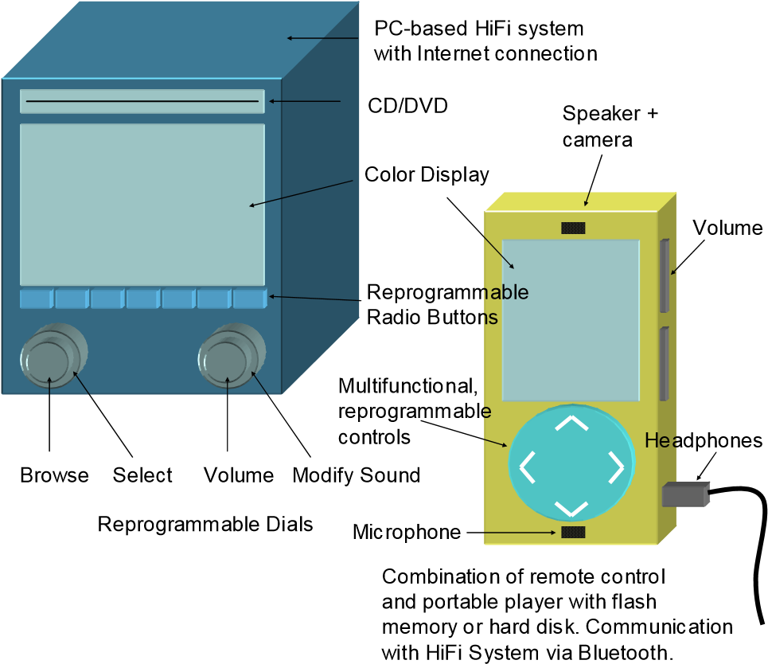

Figure 1: HiFi system connected with home device and portable player (Beauchamp, 2016).

**What are the Main Usage Scenarios?**

According to Cheung and Horner (2016), the usage scenarios proposed are much more innovative than the technical parameters of the system. We want to list only the main scenarios with some remarks on their realization.

**CD Mode:** In the CD mode the user plays an audio CD or DVD. Different from an ordinary CD player the HiFi system rips automatically the CD to the local hard disc. The hard disc comes into play in the automatic mode.

**Automatic Mode:** In the automatic mode the user simply switches the HiFi system on and the system play the songs the user likes most. The music comes either from the local hard disk or from the hard discs of other HiFi systems which form together a protected peer-to-peer sharing network.

The system uses different user inputs to “learn” the user’s flavor. A simple button like the up/down auto seek button in a car stereo enables the system to “learn” from the listener. If the user does not like a song he will press the seek button. From the automatic mode several other modes are derived.

**Browsing Mode:** In the browsing mode the user can browse through genres, artists and songs. The user is also able to select a specific song by typing the title or simply by humming the melody. Browsing results extend the user profile which is used in automatic mode. In all modes specific metadata will be displayed. This metadata is not limited to official material like title and artist. Also, recommendations or reviews from the fan community, i.e. users of other HiFi systems, or personalized advertisements can be displayed (Carlos, 2017).

**Community Mode:** In the community mode the user is enabled to chat with users who like the same music. During the listening of a certain song messages from users who like similar songs may arrive. The user is allowed to make reviews or personal rankings. Community users are often different to coach potatoes. They want to hear their favorite music everywhere.

**Portable Mode:** In the portable mode the user can transfer the music from the HiFi system’s hard disc to the storage media of the “remote control” or any other device. The user profile learned from the user’s inputs makes it very easy to find a favorite subset for the transfer to the portable. If the music content leaves the closed and protected environment of the home HiFi system we have to consider certain security technologies.

**What are the Business Models?**

Beside the consumer’s also the music producer’s situation has to be considered. Hardware manufactures want to earn money as well as most of the artists. Music labels are interested to stay in business. Therefore, they will need properly working business models that meet with the new world of instant access and easy transport of music files (Dodge, 2019).

We understand the proposed system as a service. So, a subscription model would fit most likely. Similar to the mobile phone business a customer subscribes for the service when he buys the hardware. A special music service company runs the backend system and sells the hardware. Different subscription models are possible: Buy the hardware for 1 Euro and pay the next two year every month 20 Euros. Or pay 200 Euros for the hardware and pay every month only 5 Euros. Or even pay 400 Euros to avoid any further monthly fees (Atal & Hanauer, 2017).

The music service company runs in the background an additional monitoring service which allows a fair splitting of the revenues to different artist, labels and collecting societies.

## Some already Existing Technologies

In the previous chapter we made a lot of assumptions about a future HiFi system. Although the system is not in stores yet some of the needed components and technologies already exist or are going to be developed within the next years. The already existing technologies provide commercial solutions for:

1. Transcription of song melody for recognition and user performance (Karaoke)
2. Identification of audio material for a better music look-up possibility
3. Processing of audio similarity and genre for easier music browsing
4. Sharing for instant metadata and content access building new forms of business models
5. Digitally signing of content allowing a more user friendly digital rights management.

### Browsing and Searching Functions

It is very important for a future home based HiFi system to provide easy access to large music databases. This is done by integrating comfortable search and browsing functions. Two searching technologies are already available. They are derived from research projects of Fraunhofer IDMT called Query by Humming (QbH) and AudioID (Bowcott, 2012).

In the last years the transcription of a melody excerpt from a sung user input has been developed (Chalmers, 2019). The melody recognition system Query by Humming (QbH) is useful for easy and direct access of music and for browsing in similar music. The recognition of a sung or hummed query is divided into three steps. 1st the short singing is recorded. Adaptive pre-processing reduces the influence of background noise on the succeeding steps. 2nd the fundamental frequencies are analyzed and transformed into a pitch contour which is subsequently divided into several scores. Each score is characterized by its temporal duration and tone height. 3rd a complex database lookup algorithm results a list of music titles from songs that are very close to the users singing. It compares and tries to adapt the resulted melody query phrase with all melodies stored in the database (see figure 2). Each adaptation of scores within the query phrase is noticed by a penalty value. The resulted music titles are sorted by the penalty value. The song with the lowest value i.e. the most similar one is placed at top of the list (Doty, 2017).

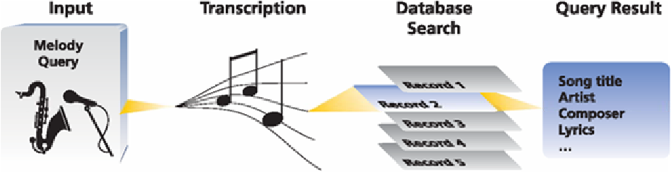

Figure 2:Functionality scheme of Fraunhofer’s (Doty, 2017).

## Advantages of a Hi-Fi System

[Hi-fi audio systems](https://www.avi-utah.com/2018/09/18/what-is-hi-fidelity-audio/) are beneficial for a number of reasons, from the quality of sound provided to the comprehensive component coverage included. Another major plus, especially when compared to other high-quality audio systems: Hi-fi systems are customizable to an incredible degree, depending on your needs for sound in various rooms and in differing noise conditions.

Each unit you include in your system has one specific task it’s meant to perform, meaning it can devote 100% of its energy to doing so. This is what helps reduce noise or distortion to bring you the best possible sound at all times.

Our subsequent sections will look into the primary components we’ll source for you when installing a McIntosh or another type of component audio system.

## Audio Sources

For starters, we’ll spend time discussing the sources of your audio ahead of time. Are you bringing in musical files from a hard drive, or do you mostly utilize streaming services like Spotify or Apple Music? If so, we’ll recommend a network player that can properly combine your tracks from each of these sources.

What about those who have an old vinyl record collection? No problem – we can help you connect a record player as part of the system. The same goes for CDs or any audio format you can think of.

## Amplifier Choice

From here, it’s time to consider the amplifier, which is in charge of powering your music and controlling volume. Depending on your needs, we may recommend a power amp, a pre-amp, an integrated amp or some other solution.

## Speakers

Finally, you have to select your speaker units to provide the actual sound itself. We’ll give you advice on the size of speakers you should consider based on room size and positioning needs, ensuring you don’t choose options that are too small or too large.

## System Cables

In addition to your actual units, we’ll arrange all your cable and wire connections simply and easily. We handle everything from basic power cables to interconnects and speaker cables, which we’ll measure to the precise length you need them so you won’t have cables hanging around or getting in your way.

For more on the components involved in a hi-fi home audio system, or to learn about any of our home automation or smart home technology, speak to the staff at [AVI Systems](https://www.avi-utah.com/) today.

**CONCLUSION**

The music business is one of the most exiting ones. But the industry behind it regards the industrial product music as much more important than the art of it. Thanks to the Internet and modern audio coding technologies people broke with the industry that has hardly been able to follow developments that already last for 10 years now. This new concept about music consumption of the future will open the door for new music business models. By integrating existing technologies future HiFi systems will bring much more comfort to the user by offering him a series of new music browsing manipulation and processing tools. Through a sharing network users will get information about artists, tours and other related events instantaneously.

**RECOMMENDATIONS**

This paper recommends the use of HIFI technology as a semantic audio processing will be a major property of the future HiFi system.

The paper also recommends that users should change from pure consumers to music artists because they will be enabled to (re)create content. Together with a very user-friendly, light weighted digital rights management system the peer-to-peer sharing network will build a marketing and distribution platform for young and often unknown artists.

**References**

Arfib, D. (2017). "Digital Synthesis of Complex Spectra by Means of Multiplication of Non-linear Distorted Sine Waves", *Journal of the Audio Engineering Society* 27(10), 757-779

Atal, B. & Hanauer, S. (2017). "Speech Analysis and Synthesis by Linear Prediction of the Speech Wave," *Journal of the Acoustical Society of America* 50(2), 637-655

Beauchamp, J. (2016). *A Computer System for Time-Variant Harmonic Analysis and Synthesis of Musical Tones*. John Wiley & Sons, New York.

Bowcott, W. (2012). Synthesis by Amplitude and 'Brightness' Matching of Analyzed Musical Instrument Tones, *Journal of the Audio Engineering Society* 30(6), 396-406.

Cann, R., (2018). An Analysis/Synthesis Tutorial. *Computer Music Journal* 3(3), 6-11

Carlos, W. (2017). Tuning: At the Crossroads. *Computer Music Journal* 11(1), 29-43

Chalmers, J. (2019). Brass-Tone Synthesis by Spectrum Evolution Matching with Nonlinear Functions," *Computer Music Journal* 3(2), 35-43.

Chan, S. & Horner, A. (2016). "Discrete Summation Synthesis of Musical Instrument Tones using Genetic Algorithms," *Journal of the Audio Engineering Society* 44(7), 581-592.

Cheung, N. & Horner, A. (2016). "Group Synthesis with Genetic Algorithms", *Journal of the Audio Engineering Society* 44(3) pp. 130-147

Dodge, N. (2019). Head-Related Transfer Function Modeling in 3-D Sound Systems with Genetic Algorithms, *Journal of the Audio Engineering Society* 46(6), 531-539.

Doty, J. (2017). The Synthesis of Complex Audio Spectra by Means of Frequency Modulation. *Journal of the Audio Engineering Society* 21(7), 526-534.